A189, A194 Afr-Egy-Ushabti-Ptolemaic Period-Blue Faïence-300 BCE-350 BCE

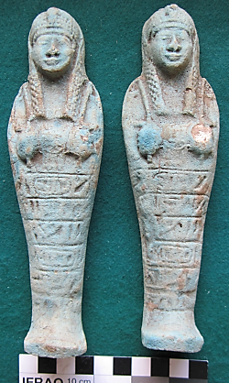

**Case No.: 2**

**Formal Label:**

**Display Description: These two nearly identical Ushabtis were made from the same impression and exhibit a Ptolemaic corkscrew wig, with hands crossed, opposite to each other, the arms are not indicated and are unsleeved. They wear the typical Ptolemaic corkscrew wig. Accession Number: 189, 194.**

**LC Classification:**

**Date or Time Horizon:**

**Geographical Area:**

**Map, GPS Coordinates:**

**Cultural Affiliation:**

**Medium:** blue faience.

**Dimensions: 189 and 194: H 6.805 in, 172,85 mm  
Weight: 189 4.5 oz, 130 gm; 194: 4.25 oz, 122 gm;**

**Provenance: unknown**

**Condition: original**

**Discussion: These represent a period during which many Ushabtis were made for the mass market and yet retain the aspect of the past in their many rows of hieroglyphs still visible on their bodies.**

**References:**

Aubert, J.-F. et L. Aubert. 1974. *Statuettes Egyptiennes: Chaouabtis, Ouchebtis.* Paris, 1974.

Janes, Glenn. 2002. *Shabtis. A Private View, Ancient Egyptian Funerary Statuettes in European Private Collections.* Paris: Cybèle.

Newberry, Percy E. 1930-1957. *Funerary Statuettes and Model Sarcophagi.*  Le Caire: Impr. de l'Institut français d'archéologie orientale.

Schneider, Hans D. 1977. *Shabtis - An Introduction to the History of Ancient Egyptian Funerary Statuettes. With a Catalogue of the Collection of Shabtis in the National Museum of Leiden*. (3 volumes, Leiden: Rijksmuseum van Oudheden Te Leiden.

Schlögl, Hermann and Andreas Brodbeck. 1990. *Ägyptische Totenfiguren aus öffentlichen und privaten Sammlungen der Schweiz.* Orbis Biblicus et Orientalis, Series Archeologica, 7. Göttingen, Vandenhoeck & Ruprecht; Freiburg Schweiz, Universitätsverlag.